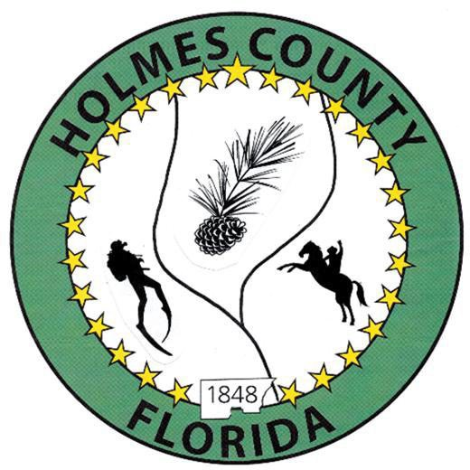
HOLMES COUNTY BOARD OF COUNTY COMMISSIONERS
December 02, 2025 Regular Session 6:00 PM
Commission Board Room - 107 E Virginia Ave., Bonifay, FL 32425

David Corbin
Project Director
Nate Nolin
County Attorney

WILMER STAFFORD |  | MITCH JOHNSON EARL STAFFORD | CLINT ERICKSON
District 1 | District 2 | District 3 District 4 | District 5

PROCLAMATION
- Call to Order
- Invocation/Pledge

ADOPT THE AGENDA
- Additions or Deletions

ADOPT PREVIOUS MINUTES

Regular Session – November 18, 2025

NON- AGENDA AUDIENCE
Effective October 1, 2013, Florida Statute 286.0114 mandates that “members of the public shall be given a reasonable opportunity to be heard on a proposition before a Board or Commission.” Each individual shall have three (3) minutes to speak on the proposition before the Board.

AGENDA ITEMS

Rain Days, Road Department

TCCC Public Sector Appointment

Reddick Mill Road, Pond Cleanout

COUNTY COORDINATOR

FEMA

BUILDING OFFICIAL / PLANNING

Immediate Family Exception – John Feeney

LIBERTY PARTNERS

COUNTY ENGINEER
- Dewberry Engineering
- Melvin Engineering
- SEC & ELR Change Orders – Pilot Infrastructure Project
- Alday – Howell Engineering
- Hanson Professional Services

COUNTY ATTORNEY

COMMISSIONER ITEMS

Road & Bridge, Pay Scale – Clint Erickson

Discussion regarding payments for New Kenworth Dump Trucks – Clint Erickson

Stipend Pay – Wilmer Stafford

2026 Night Meetings Start Time Discussion – Wilmer Stafford

ADJOURN

