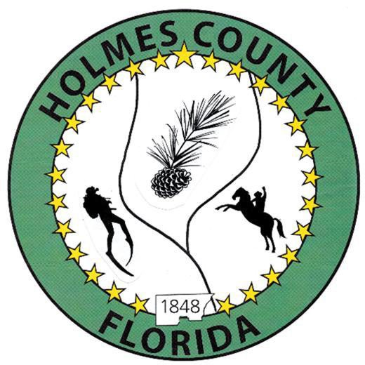
HOLMES COUNTY BOARD OF COUNTY COMMISSIONERS
November 18, 2025 Regular Session 9:00 AM
Commission Board Room - 107 E Virginia Ave., Bonifay, FL 32425

David Corbin
Project Director
Nate Nolin
County Attorney

WILMER STAFFORD |  | MITCH JOHNSON EARL STAFFORD | CLINT ERICKSON
District 1 | District 2 | District 3 District 4 | District 5

PROCLAMATION
- Call to Order
- Invocation/Pledge

ADOPT THE AGENDA
- Additions or Deletions

ADOPT PREVIOUS MINUTES

Special Budget Session – November 03, 2025

Regular Session – November 04, 2025

Corrected Special Session - September 04, 2025

NON- AGENDA AUDIENCE
Effective October 1, 2013, Florida Statute 286.0114 mandates that “members of the public shall be given a reasonable opportunity to be heard on a proposition before a Board or Commission.” Each individual shall have three (3) minutes to speak on the proposition before the Board.

AGENDA ITEMS

2026 Holiday Schedule

Agreement – Holmes County Jail and Rehabilitation Expansion

Final 2024-2025 Budget Amendment – Angie Purvee

COUNTY COORDINATOR

FEMA

BUILDING OFFICIAL / PLANNING

Coleman Family Secondary Residence Exemption – John Feeney

LIBERTY PARTNERS

EMS Construction Management

COUNTY ENGINEER
- Dewberry Engineering
- Melvin Engineering
- Alday – Howell Engineering
- Hanson Professional Services

COUNTY ATTORNEY

Bid Opening – 1973 Jesses Way

COMMISSIONER ITEMS

Advertising for Engineers – Clint Erickson

Caution Lights on Hwy 2 & Hwy 2A – Clint Erickson

Set Date/Time for Dogwood Lakes Informational MSBU Meeting – Wilmer Stafford

Lake Cassidy Passes – Wilmer Stafford

ADJOURN

