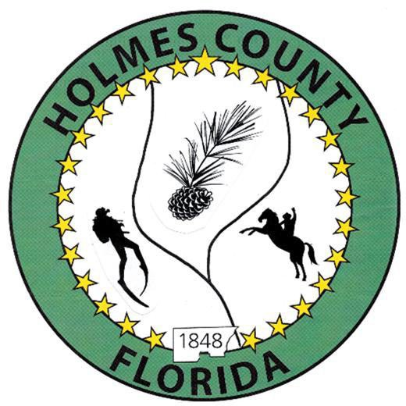
HOLMES COUNTY BOARD OF COUNTY COMMISSIONERS
November 04, 2025 Regular Session 6:00 PM
Commission Board Room - 107 E Virginia Ave., Bonifay, FL 32425

David Corbin
Project Director
Nate Nolin
County Attorney

WILMER STAFFORD |  | MITCH JOHNSON EARL STAFFORD | CLINT ERICKSON
District 1 | District 2 | District 3 District 4 | District 5

PROCLAMATION
- Call to Order
- Invocation/Pledge

ADOPT THE AGENDA
- Additions or Deletions

ADOPT PREVIOUS MINUTES

Regular Session – October 21, 2025

NON- AGENDA AUDIENCE
Effective October 1, 2013, Florida Statute 286.0114 mandates that “members of the public shall be given a reasonable opportunity to be heard on a proposition before a Board or Commission.” Each individual shall have three (3) minutes to speak on the proposition before the Board.

AGENDA ITEMS

Motor Grader Lease

Miss Holmes County Pageant – Amanda Hickman

Board Schedule 2026

Holiday Schedule 2026

COUNTY COORDINATOR

Bid Opening – Bear Hewett Property

FEMA

BUILDING OFFICIAL / PLANNING

LIBERTY PARTNERS

COUNTY ENGINEER
- Dewberry Engineering
- John Clark Road Project Closeout (Resolution 25-29 & Supplemental Agreement)
- Melvin Engineering
- Alday – Howell Engineering
  - Dogwood Lakes
- Hanson Professional Services

COUNTY ATTORNEY

MSBU Dogwood Lakes
- Lake Cassiday Disclaimer & Interlocal Agreement
- HCDC Board Reorganization

COMMISSIONER ITEMS

ADJOURN

