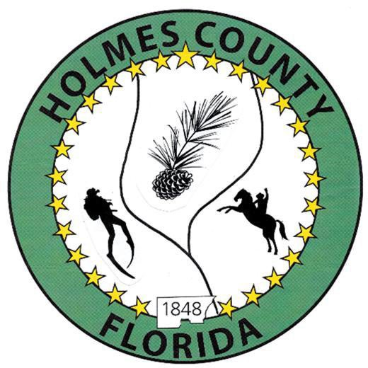
HOLMES COUNTY BOARD OF COUNTY COMMISSIONERS
October 21, 2025 Regular Session 9:00 AM
Commission Board Room - 107 E Virginia Ave., Bonifay, FL 32425

David Corbin
Project Director
Nate Nolin
County Attorney

WILMER STAFFORD |  | MITCH JOHNSON EARL STAFFORD | CLINT ERICKSON
District 1 | District 2 | District 3 District 4 | District 5

PROCLAMATION
- Call to Order
- Invocation/Pledge

ADOPT THE AGENDA
- Additions or Deletions

ADOPT PREVIOUS MINUTES

Regular Session – October 07, 2025

NON- AGENDA AUDIENCE
Effective October 1, 2013, Florida Statute 286.0114 mandates that “members of the public shall be given a reasonable opportunity to be heard on a proposition before a Board or Commission.” Each individual shall have three (3) minutes to speak on the proposition before the Board.

AGENDA ITEMS

Medical Examiner Funding Contract FY 2025-2026

Issue RFP for Health Insurance FY 2026-2027

Kenworth Dump Truck Quotes - Jay Callaway, Truckworx

COUNTY COORDINATOR

Motor Grader Leases

FEMA

BUILDING OFFICIAL / PLANNING

LIBERTY PARTNERS

COUNTY ENGINEER
- Dewberry Engineering
  - Contract Extension
  - Bid Award – BSCOP Peak Road Bridge
  - Bid Award – BSCOP Roping Road Bridge
  - John Clark Road Project Closeout
- Melvin Engineering
- Alday – Howell Engineering
  - Contract Extension
- Hanson Professional Services

COUNTY ATTORNEY

COMMISSIONER ITEMS
- Lake Cassidy Disclaimer - Wilmer Stafford

ADJOURN

