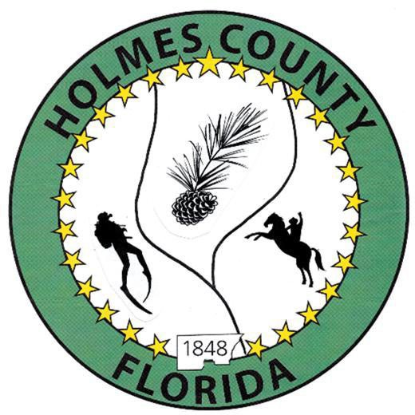
HOLMES COUNTY BOARD OF COUNTY COMMISSIONERS
November 03, 2025 Special Session 5:01 PM
Commission Board Room - 107 E Virginia Ave., Bonifay, FL 32425

David Corbin
Project Director
Nate Nolin
County Attorney

WILMER STAFFORD |  | MITCH JOHNSON EARL STAFFORD | CLINT ERICKSON
District 1 | District 2 | District 3 District 4 | District 5

PROCLAMATION
- Call to Order
- Invocation/Pledge

ADOPT THE AGENDA
- Additions or Deletions

ADOPT PREVIOUS MINUTES

NON- AGENDA AUDIENCE
Effective October 1, 2013, Florida Statute 286.0114 mandates that “members of the public shall be given a reasonable opportunity to be heard on a proposition before a Board or Commission.” Each individual shall have three (3) minutes to speak on the proposition before the Board.

AGENDA ITEMS

Final Budget Hearing

COUNTY COORDINATOR

FEMA

BUILDING OFFICIAL / PLANNING

LIBERTY PARTNERS

COUNTY ENGINEER
- Dewberry Engineering
- Melvin Engineering
- Alday – Howell Engineering
- Hanson Professional Services

COUNTY ATTORNEY

COMMISSIONER ITEMS

ADJOURN

