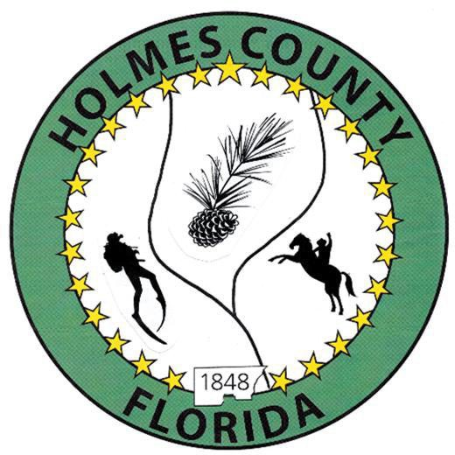
HOLMES COUNTY BOARD OF COUNTY COMMISSIONERS
April 07, 2026 Regular Session 6:00 PM
Commission Board Room - 107 E Virginia Ave., Bonifay, FL 32425

David Corbin
Project Director
Nate Nolin
County Attorney

WILMER STAFFORD | WADE ELLENBURG | MITCH JOHNSON EARL STAFFORD | CLINT ERICKSON
District 1 | District 2 | District 3 District 4 | District 5

PROCLAMATION
- Call to Order
- Invocation/Pledge

ADOPT THE AGENDA
- Additions or Deletions

ADOPT PREVIOUS MINUTES

Regular Session – March 17, 2026

NON- AGENDA AUDIENCE
Effective October 1, 2013, Florida Statute 286.0114 mandates that “members of the public shall be given a reasonable opportunity to be heard on a proposition before a Board or Commission.” Each individual shall have three (3) minutes to speak on the proposition before the Board.

AGENDA ITEMS
- Single Member District – Eddie Nelson
- Bonifay Gritney Phase II, Resolution 26-05 and Supplemental Agreement 04 – Jane Dellwo
- Finalization Ditch Dirt Policy – Wade Ellenburg
- Library Maintenance and Grant – Becky Marsh
- Bid Selection/Approval, 2245 Yoopon Lane, Bonifay – Robin Phillips

COUNTY COORDINATOR

Authorization to Hire Police Officer for Holidays

FEMA

BUILDING OFFICIAL / PLANNING

LIBERTY PARTNERS

COUNTY ENGINEER
- Dewberry Engineering
- Melvin Engineering
- Alday – Howell Engineering
- Hanson Professional Services

COUNTY ATTORNEY

Ditch Dirt Policy

COMMISSIONER ITEMS

District 5 Development Commission Appointment – Clint Erickson

Hwy 177A Public Park at Dogwood Lakes Entrance – Clint Erickson

CDL Requirement Discussion, Road Department – Wade Ellenburg

Lake Cassidy Passes – Wilmer Stafford

ADJOURN

