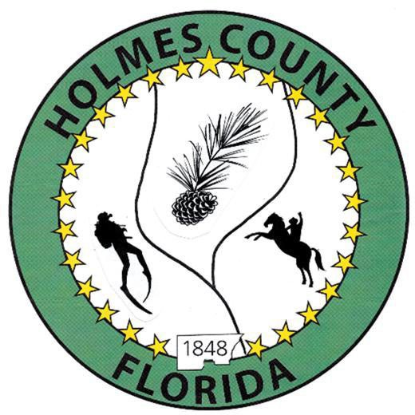
HOLMES COUNTY BOARD OF COUNTY COMMISSIONERS
April 21, 2026 Regular Session 9:00 AM
Commission Board Room - 107 E Virginia Ave., Bonifay, FL 32425

David Corbin
Project Director
Nate Nolin
County Attorney

WILMER STAFFORD | WADE ELLENBURG | MITCH JOHNSON EARL STAFFORD | CLINT ERICKSON
District 1 | District 2 | District 3 District 4 | District 5

PROCLAMATION
- Call to Order
- Invocation/Pledge

ADOPT THE AGENDA
- Additions or Deletions

ADOPT PREVIOUS MINUTES

Regular Session – April 07, 2026

NON- AGENDA AUDIENCE
Effective October 1, 2013, Florida Statute 286.0114 mandates that “members of the public shall be given a reasonable opportunity to be heard on a proposition before a Board or Commission.” Each individual shall have three (3) minutes to speak on the proposition before the Board.

AGENDA ITEMS

Upward Communities – Jason Roberts

SHIP, Croft Satisfaction of Mortgage – Jane Dellwo

COUNTY COORDINATOR

FEMA

BUILDING OFFICIAL / PLANNING

LIBERTY PARTNERS

COUNTY ENGINEER
- Dewberry Engineering
- Melvin Engineering
- Alday – Howell Engineering

Closeout – CR 181 Phases I & II – Bowden Howell
- Hanson Professional Services

COUNTY ATTORNEY

Opioid Litigation Update & Resolution

COMMISSIONER ITEMS

Spring Valley/Turberville Road Bridge – Earl Stafford

ADJOURN

