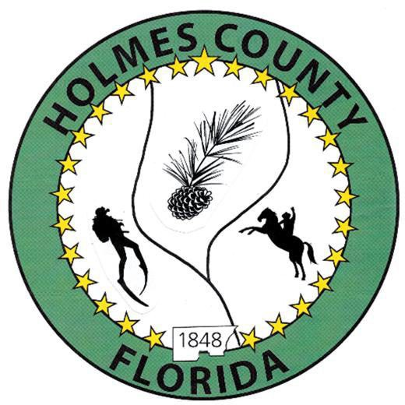
HOLMES COUNTY BOARD OF COUNTY COMMISSIONERS
August 04, 2026 Regular Session 6:00 PM
Commission Board Room - 107 E Virginia Ave., Bonifay, FL 32425

David Corbin
Project Director
Nate Nolin
County Attorney

WILMER STAFFORD | WADE ELLENBURG | MITCH JOHNSON EARL STAFFORD | CLINT ERICKSON
District 1 | District 2 | District 3 District 4 | District 5

PROCLAMATION
- Call to Order
- Invocation/Pledge

ADOPT THE AGENDA
- Additions or Deletions

ADOPT PREVIOUS MINUTES

Budget Workshop – July 21, 2026

Regular Session – July 21, 2026

NON- AGENDA AUDIENCE
Effective October 1, 2013, Florida Statute 286.0114 mandates that “members of the public shall be given a reasonable opportunity to be heard on a proposition before a Board or Commission.” Each individual shall have three (3) minutes to speak on the proposition before the Board.

AGENDA ITEMS

EMS – Sheriff John Tate

Time Extension Agreement, H2525 – Jane Dellwo

Bonifay Gritney SA #5 and Resolution – Jane Dellwo

79 Corridor - DEO Grant Assignment and Assumption – Jane Dellwo

FRDAP Grant Application Cycle – Jane Dellwo

Quotes on Motor Graders – Andy Tharp

Termination of the Interlocal Agreement Establishing the Choctawhatchee Bay Estuary Coalition – Melinda Gates

Choctawhatchee Basin Alliance Estuary Program Adoption Agreement – Melida Gates

Appointments to the Choctawhatchee Basin Alliance Estuary Program Steering Council – Melinda Gates
- Department of Agriculture, Emergency Watershed Program – Phillip Slater & Brandon McCray
- Library Programs - Becky Marsh

COUNTY COORDINATOR

Lobby Services Renewal – David Corbin

Operating Budget, Road and Bridge – David Corbin

FEMA

DEVELOPMENT COMMISSION

BUILDING OFFICIAL / PLANNING

Secondary Residence Exemption, Parcel ID 1332.00-000-000-019.000 – John Feeney

Secondary Residence Exemption, Parcel ID 0801.00-000-000-015.100 – John Feeney

LIBERTY PARTNERS

COUNTY ENGINEER
- Dewberry Engineering
- Melvin Engineering
- Alday – Howell Engineering
- Hanson Professional Services

COUNTY ATTORNEY

COMMISSIONER ITEMS

Paving Estimates, Spring Hill and Chance Roads – Clint Erickson

ADJOURN

