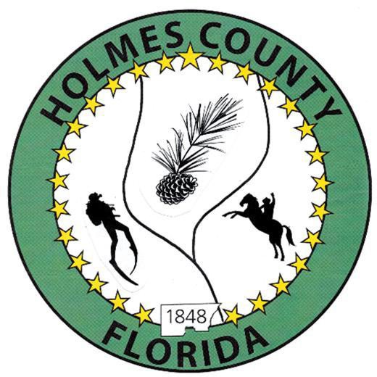
HOLMES COUNTY BOARD OF COUNTY COMMISSIONERS
February 03, 2026 Regular Session 6:00 PM
Commission Board Room - 107 E Virginia Ave., Bonifay, FL 32425

David Corbin
Project Director
Nate Nolin
County Attorney

WILMER STAFFORD | WADE ELLENBURG | MITCH JOHNSON EARL STAFFORD | CLINT ERICKSON
District 1 | District 2 | District 3 District 4 | District 5

PROCLAMATION
- Call to Order
- Invocation/Pledge

ADOPT THE AGENDA
- Additions or Deletions

ADOPT PREVIOUS MINUTES

Regular Session – January 20, 2026

NON- AGENDA AUDIENCE
Effective October 1, 2013, Florida Statute 286.0114 mandates that “members of the public shall be given a reasonable opportunity to be heard on a proposition before a Board or Commission.” Each individual shall have three (3) minutes to speak on the proposition before the Board.

AGENDA ITEMS

2026 FPL Economic Symposium

Legend Way, Clear Existing Property for Road off Little John Lane – Clint Erickson

Discussion: Abandonment of County Owned Lakes via Resolution – Clint Erickson

Resolution 26-03 for FDOT Off System Agreement – Jane Dellwo

Wheeler Invoice

COUNTY COORDINATOR

FEMA

BUILDING OFFICIAL / PLANNING

Minor Development Order, PDL Borrow Pit – John Feeney

LIBERTY PARTNERS

COUNTY ENGINEER
- Dewberry Engineering
- Melvin Engineering
- Construction Agreement, Project Gateway - Rod Adams
- Alday – Howell Engineering
- Hanson Professional Services

COUNTY ATTORNEY

Metric Consulting Agreement (RFP 25-57)

COMMISSIONER ITEMS

ADJOURN

