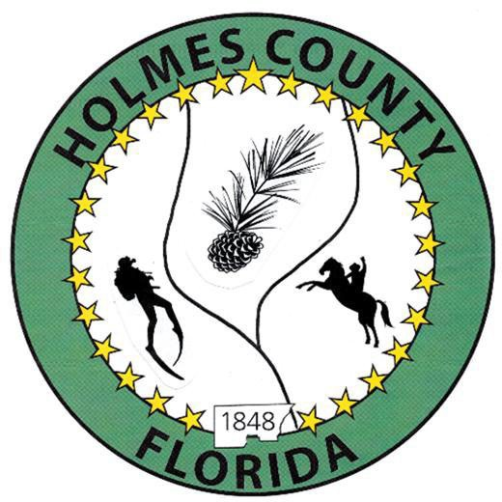
HOLMES COUNTY BOARD OF COUNTY COMMISSIONERS
February 17, 2026 Regular Session 9:00 AM
Commission Board Room - 107 E Virginia Ave., Bonifay, FL 32425

David Corbin
Project Director
Nate Nolin
County Attorney

WILMER STAFFORD | WADE ELLENBURG | MITCH JOHNSON EARL STAFFORD | CLINT ERICKSON
District 1 | District 2 | District 3 District 4 | District 5

PROCLAMATION
- Call to Order
- Invocation/Pledge

ADOPT THE AGENDA
- Additions or Deletions

ADOPT PREVIOUS MINUTES

Regular Session – February 03, 2026

NON- AGENDA AUDIENCE
Effective October 1, 2013, Florida Statute 286.0114 mandates that “members of the public shall be given a reasonable opportunity to be heard on a proposition before a Board or Commission.” Each individual shall have three (3) minutes to speak on the proposition before the Board.

AGENDA ITEMS
- OAWP Lease Agreement Renewal – Kalyn Waters
- No-Trill Drill Income – Kalyn Waters
- Griffin Traffic Signals Contract Agreement Renewal
- Memorial Sign on CR 179 – Sherel Crews
- 2026 Household Hazardous Waste Amnesty Day – Saturday, February 28, 2026 from 8am-12pm
- Move Early March Meeting to Monday, March 02, 2026 at 6:00pm – Jane Dellwo
- Resolution 26-XX to Apply for FDOT Programs (CIGP, SCRAP, SCOP, BSCOP)
- iWorq Upgrade for Road Department to Include Resident Interface – Jane Dellwo
- Jail Expansion – Sheriff John Tate
- Crime Stopper Trust Fund Grant, Letter of Agreement – Jessica Chase
- Modern Tech Squad, Audio Upgrade – Matt Watkins

COUNTY COORDINATOR

FEMA

BUILDING OFFICIAL / PLANNING

Dickinson Family Secondary Residence Exemption – John Feeney

LIBERTY PARTNERS

Grant Opportunity Availability Discussion

COUNTY ENGINEER
- Dewberry Engineering
- Melvin Engineering
- Alday – Howell Engineering
- Hanson Professional Services

COUNTY ATTORNEY

COMMISSIONER ITEMS

ADJOURN

