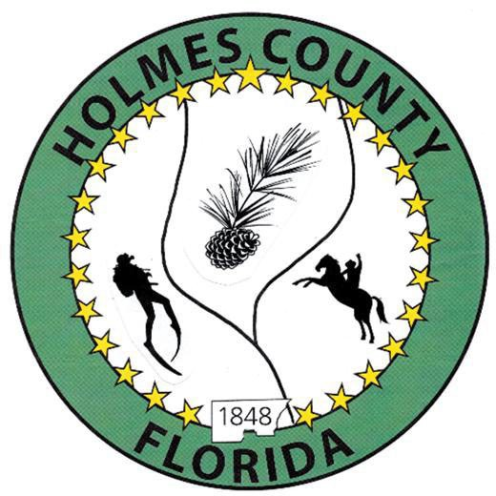
HOLMES COUNTY BOARD OF COUNTY COMMISSIONERS
January 20, 2026 Regular Session 9:00 AM
Commission Board Room - 107 E Virginia Ave., Bonifay, FL 32425

David Corbin
Project Director
Nate Nolin
County Attorney

WILMER STAFFORD | WADE ELLENBURG | MITCH JOHNSON EARL STAFFORD | CLINT ERICKSON
District 1 | District 2 | District 3 District 4 | District 5

PROCLAMATION
- Call to Order
- Invocation/Pledge

ADOPT THE AGENDA
- Additions or Deletions

ADOPT PREVIOUS MINUTES

Regular Session – January 06, 2026

NON- AGENDA AUDIENCE
Effective October 1, 2013, Florida Statute 286.0114 mandates that “members of the public shall be given a reasonable opportunity to be heard on a proposition before a Board or Commission.” Each individual shall have three (3) minutes to speak on the proposition before the Board.

AGENDA ITEMS
- Award for Emergency Management and Disaster Response Services
- SCRAP/SCOP/BSCOP/CIGP: Applications due 03.26.2026
- Liaison Appointments 2026
- Donations of Proceeds of Sale of Parcel# 0908.04-004-000-009.000 – Dubin Acquisitions, LLC
- Safe Haven Baby Box, Cross Point Church of PDL – Pastor Michael Tadlock & Kayla Johnson
- Bodie Lane Discussion – Charles Ward

COUNTY COORDINATOR

FEMA

BUILDING OFFICIAL / PLANNING

Fenlon Family Exception, Second Residence – John Feeney

Bailey Family Exception, Second Residence – John Feeney

LIBERTY PARTNERS

COUNTY ENGINEER
- Dewberry Engineering
- Melvin Engineering
- Alday – Howell Engineering
- Hanson Professional Services
  - Turberville Road Bridge Replacement – Brian Lemieux

COUNTY ATTORNEY

COMMISSIONER ITEMS
- Easements: Smith Chapel Road and Grover Lewis Road - Wilmer Stafford
- Clearing at Ponce de Leon Fire Department – Wilmer Stafford
- Proposed easement through south side of Parcel# 1232.00-000-000-0015.000 – Wilmer Stafford

ADJOURN

