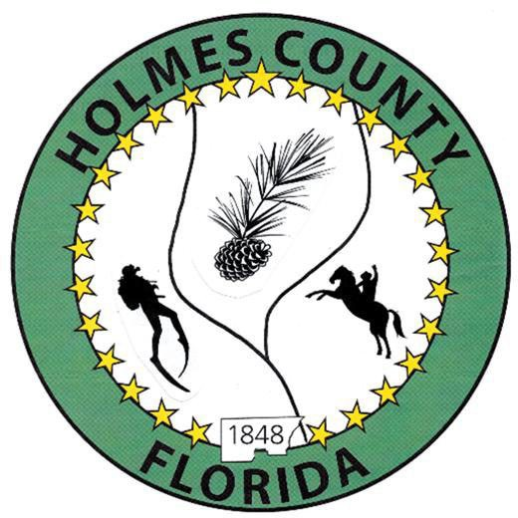
HOLMES COUNTY BOARD OF COUNTY COMMISSIONERS
June 02, 2026 Regular Session 6:00 PM
Commission Board Room - 107 E Virginia Ave., Bonifay, FL 32425

David Corbin
Project Director
Nate Nolin
County Attorney

WILMER STAFFORD | WADE ELLENBURG | MITCH JOHNSON EARL STAFFORD | CLINT ERICKSON
District 1 | District 2 | District 3 District 4 | District 5

PROCLAMATION
- Call to Order
- Invocation/Pledge

ADOPT THE AGENDA
- Additions or Deletions

ADOPT PREVIOUS MINUTES

Regular Session – May 19, 2026

NON- AGENDA AUDIENCE
Effective October 1, 2013, Florida Statute 286.0114 mandates that “members of the public shall be given a reasonable opportunity to be heard on a proposition before a Board or Commission.” Each individual shall have three (3) minutes to speak on the proposition before the Board.

AGENDA ITEMS
- RFP 26-04 Health Care Insurance Services
- 2025-2026 Budget Amendment #2 – Angie Purvee

COUNTY COORDINATOR

Agreement – Holmes County Government Efficiency Complex Project – David Corbin

Operating Supplies Budget, Road Department – David Corbin

Budget 2026-2027 Discussion – David Corbin

FEMA

DEVELOPMENT COMMISSION

BUILDING OFFICIAL / PLANNING

LIBERTY PARTNERS

COUNTY ENGINEER
- Dewberry Engineering
- Melvin Engineering
  - Pilot Infrastructure Improvements Project Closeout - Rod Adams
  - Bonifay Gritney Phase II, Change Order #3 – Jake Mathis
- Alday – Howell Engineering
- Hanson Professional Services

COUNTY ATTORNEY

Proposed Abandonment Happy Hollow Road – Nate Nolin

Proposed Land Swap – HCDC – Nate Nolin

Safe Haven Baby Box Workshop Discussion – Nate Nolin

Assignment and Assumption of DEO Grant, Approval of Dissolution of Hwy 79 Corridor Authority – Nate Nolin

COMMISSIONER ITEMS

Springhill Road Resurfacing – Clint Erickson

Data Center Discussion – Wilmer Stafford
ADJOURN

