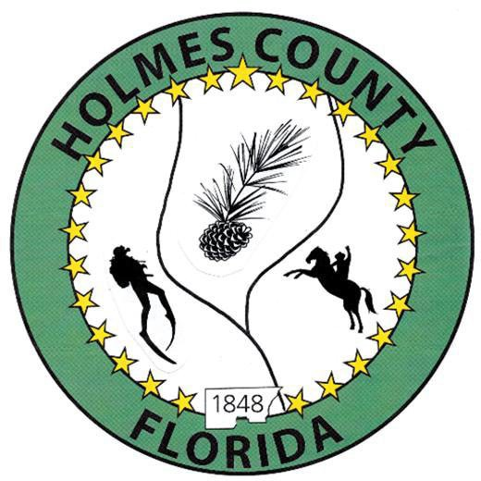
HOLMES COUNTY BOARD OF COUNTY COMMISSIONERS
June 16, 2026 Regular Session 6:00 PM
Bonifay K-8 School – 140 Blue Devil Drive, Bonifay, FL 32425

David Corbin
Project Director
Nate Nolin
County Attorney

WILMER STAFFORD | WADE ELLENBURG | MITCH JOHNSON EARL STAFFORD | CLINT ERICKSON
District 1 | District 2 | District 3 District 4 | District 5

PROCLAMATION
- Call to Order
- Invocation/Pledge

ADOPT THE AGENDA
- Additions or Deletions

ADOPT PREVIOUS MINUTES

Regular Session – June 02, 2026

NON- AGENDA AUDIENCE
Effective October 1, 2013, Florida Statute 286.0114 mandates that “members of the public shall be given a reasonable opportunity to be heard on a proposition before a Board or Commission.” Each individual shall have three (3) minutes to speak on the proposition before the Board.

AGENDA ITEMS

Public Hearing, Moratorium – Nate Nolin

Holmes County Designated Receiving System and Behavioral Health Transportation Plans for 2026–2029

– Lexi Smith

COUNTY COORDINATOR

Agreement – Holmes County Government Efficiency Complex Project – David Corbin

FEMA

DEVELOPMENT COMMISSION

BUILDING OFFICIAL / PLANNING

LIBERTY PARTNERS

COUNTY ENGINEER
- Dewberry Engineering
- Melvin Engineering
  - Bonifay Gritney Phase II, Change Order #3 – Jake Mathis
  - Pilot Infrastructure Improvements Project Closeout - Rod Adams
- Alday – Howell Engineering
- Hanson Professional Services

COUNTY ATTORNEY

Assignment and Assumption of DEO Grant, Approval of Dissolution of Hwy 79 Corridor Authority – Nate Nolin

COMMISSIONER ITEMS

Paving Estimates, Spring Hill and Chance Roads – Clint Erickson

ADJOURN

