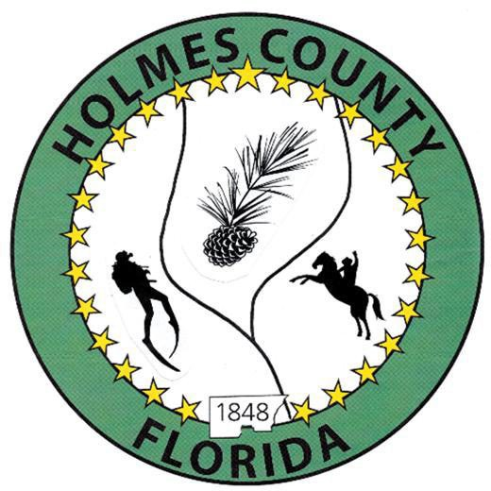
HOLMES COUNTY BOARD OF COUNTY COMMISSIONERS
March 02, 2026 Regular Session 6:00 PM
Commission Board Room - 107 E Virginia Ave., Bonifay, FL 32425

David Corbin
Project Director
Nate Nolin
County Attorney

WILMER STAFFORD | WADE ELLENBURG | MITCH JOHNSON EARL STAFFORD | CLINT ERICKSON
District 1 | District 2 | District 3 District 4 | District 5

PROCLAMATION
- Call to Order
- Invocation/Pledge

ADOPT THE AGENDA
- Additions or Deletions

ADOPT PREVIOUS MINUTES

Regular Session – February 17, 2026

NON- AGENDA AUDIENCE
Effective October 1, 2013, Florida Statute 286.0114 mandates that “members of the public shall be given a reasonable opportunity to be heard on a proposition before a Board or Commission.” Each individual shall have three (3) minutes to speak on the proposition before the Board.

AGENDA ITEMS
- Tri-County Airport Authority Update – Danny Exum
- Fiscal and Legal Impacts of the 287(g) agreement between the Sheriff’s Office and ICE – Kelley Peak
- 2025-2026 Budget Amendment #1 – Angie Purvee
- Insurance Presentation – Ryan Mims
- West Florida Electric Fee for Bonifay Gritney
- Chamber Invoice, Rural Counties Day

COUNTY COORDINATOR

FEMA

BUILDING OFFICIAL / PLANNING

ICC/Building Department Fee Schedule – Keith Bennett

Williamson Land Use Amendment – John Feeney

LIBERTY PARTNERS

COUNTY ENGINEER
- Dewberry Engineering
- Melvin Engineering
  - Change Order #1 Bonifay Gritney - Jake Mathis
- Alday – Howell Engineering
- Hanson Professional Services

COUNTY ATTORNEY

Tritech Perpetual Easement Discussion

Task Work Order EM Services, Metric Consulting

COMMISSIONER ITEMS

ADJOURN

