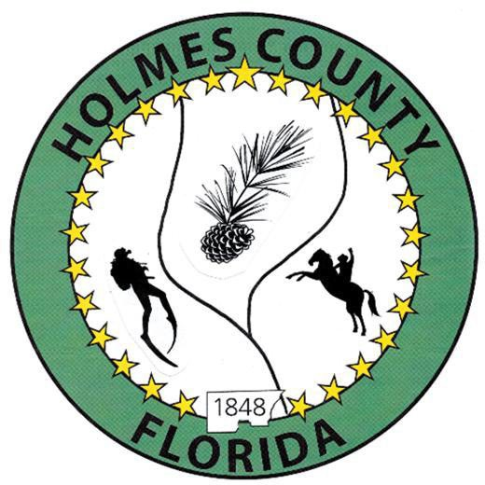
HOLMES COUNTY BOARD OF COUNTY COMMISSIONERS
May 05, 2026 Regular Session 6:00 PM
Commission Board Room - 107 E Virginia Ave., Bonifay, FL 32425

David Corbin
Project Director
Nate Nolin
County Attorney

WILMER STAFFORD | WADE ELLENBURG | MITCH JOHNSON EARL STAFFORD | CLINT ERICKSON
District 1 | District 2 | District 3 District 4 | District 5

PROCLAMATION
- Call to Order
- Invocation/Pledge

ADOPT THE AGENDA
- Additions or Deletions

ADOPT PREVIOUS MINUTES

Regular Session – April 21, 2026

NON- AGENDA AUDIENCE
Effective October 1, 2013, Florida Statute 286.0114 mandates that “members of the public shall be given a reasonable opportunity to be heard on a proposition before a Board or Commission.” Each individual shall have three (3) minutes to speak on the proposition before the Board.

AGENDA ITEMS
- School Board Referendum – Buddy Brown
- Chain of Command Discussion
- Library HVAC – Becky Marsh

COUNTY COORDINATOR

FEMA

BUILDING OFFICIAL / PLANNING

Peters Family Secondary Residence Exemption – John Feeney

LIBERTY PARTNERS

COUNTY ENGINEER
- Dewberry Engineering
- Melvin Engineering
- Alday – Howell Engineering
- Hanson Professional Services

COUNTY ATTORNEY

COMMISSIONER ITEMS
- Development Commission Appointment, District 5 – Clint Erickson

ADJOURN

