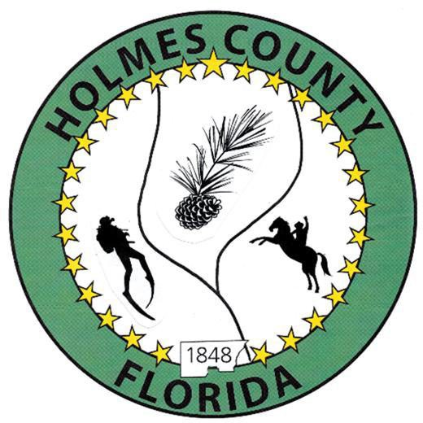
HOLMES COUNTY BOARD OF COUNTY COMMISSIONERS
May 19, 2026 Regular Session 9:00 AM
Commission Board Room - 107 E Virginia Ave., Bonifay, FL 32425

David Corbin
Project Director
Nate Nolin
County Attorney

WILMER STAFFORD | WADE ELLENBURG | MITCH JOHNSON EARL STAFFORD | CLINT ERICKSON
District 1 | District 2 | District 3 District 4 | District 5

PROCLAMATION
- Call to Order
- Invocation/Pledge

ADOPT THE AGENDA
- Additions or Deletions

ADOPT PREVIOUS MINUTES

Regular Session – May 05, 2026

Special Session – May 11, 2026

NON- AGENDA AUDIENCE
Effective October 1, 2013, Florida Statute 286.0114 mandates that “members of the public shall be given a reasonable opportunity to be heard on a proposition before a Board or Commission.” Each individual shall have three (3) minutes to speak on the proposition before the Board.

AGENDA ITEMS

LMS Resolution – Barry Lee

Building Safety Month Promotion – Keith Bennett

Task Order Old Mill Road, CEI DHM Engineering – Jane Dellwo

CDBG Bid Award – Robin Phillips

COUNTY COORDINATOR

Reimbursement to District 1 for Hwy 10A – David Corbin

Fire Department - David Corbin

FEMA

BUILDING OFFICIAL / PLANNING

LIBERTY PARTNERS

Holmes County Jail Expansion RFQ for Design & Engineering Services – Tim Parson

COUNTY ENGINEER
- Dewberry Engineering
- Melvin Engineering
  - Change Order #2, Bonifay-Gritney Road – Jake Mathis
- Alday – Howell Engineering
- Hanson Professional Services

COUNTY ATTORNEY

COMMISSIONER ITEMS

Employee Pay Study – Clint Erickson

Development Council Representation – Clint Erickson

Port-O Potty for Cork Harris Landing – Wilmer Stafford

ADJOURN

