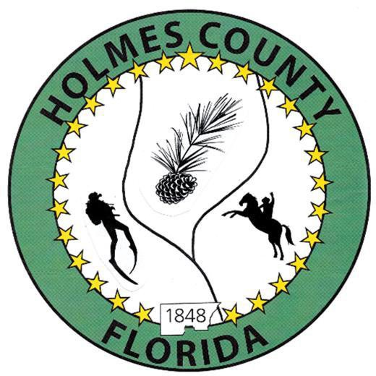
HOLMES COUNTY BOARD OF COUNTY COMMISSIONERS
October 06, 2026 Regular Session 6:00 PM
Commission Board Room - 107 E Virginia Ave., Bonifay, FL 32425

David Corbin
Project Director
Nate Nolin
County Attorney

WILMER STAFFORD | WADE ELLENBURG | MITCH JOHNSON EARL STAFFORD | CLINT ERICKSON
District 1 | District 2 | District 3 District 4 | District 5

PROCLAMATION
- Call to Order
- Invocation/Pledge

ADOPT THE AGENDA
- Additions or Deletions

ADOPT PREVIOUS MINUTES

Special Session – September 15, 2026

Regular Session – September 15, 2026

Final Budget Hearing – September 28, 2026

Special Session – September 28, 2026

NON- AGENDA AUDIENCE
Effective October 1, 2013, Florida Statute 286.0114 mandates that “members of the public shall be given a reasonable opportunity to be heard on a proposition before a Board or Commission.” Each individual shall have three (3) minutes to speak on the proposition before the Board.

AGENDA ITEMS

Secondary Residence Exemption, Stewart – John Feeney

Ordinance 26-06, Kneller Small Scale Amendment – John Fenney

FDACS Contract – Lee Duke

COUNTY COORDINATOR

Medical Examiner Services Interlocal Agreement FY27 – David Corbin

FEMA

DEVELOPMENT COMMISSION

BUILDING OFFICIAL / PLANNING

LIBERTY PARTNERS

COUNTY ENGINEER
- Dewberry Engineering
- Melvin Engineering
  - Old Mill Road, Change Order, No 1 – Jake Mathis
- Alday – Howell Engineering
- Hanson Professional Services

COUNTY ATTORNEY

COMMISSIONER ITEMS

Garbage Franchise Contracts – Clint Erickson

Pine Straw Alley – Earl Stafford

County Policy, Reporting and Travel – Wade Ellenburg

ADJOURN

