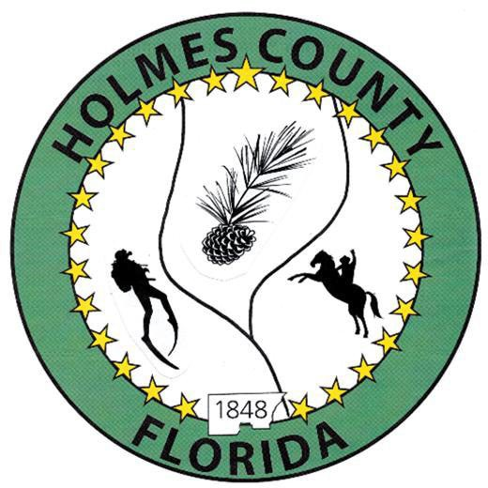
HOLMES COUNTY BOARD OF COUNTY COMMISSIONERS
September 15, 2026 Regular Session 9:00 AM
Commission Board Room - 107 E Virginia Ave., Bonifay, FL 32425

David Corbin
Project Director
Nate Nolin
County Attorney

WILMER STAFFORD | WADE ELLENBURG | MITCH JOHNSON EARL STAFFORD | CLINT ERICKSON
District 1 | District 2 | District 3 District 4 | District 5

PROCLAMATION
- Call to Order
- Invocation/Pledge

ADOPT THE AGENDA
- Additions or Deletions

ADOPT PREVIOUS MINUTES

Special Session – September 01, 2026

Regular Session – September 01, 2026

Special Session – September 04, 2026

Tentative Budget Hearing – September 09, 2026

NON- AGENDA AUDIENCE
Effective October 1, 2013, Florida Statute 286.0114 mandates that “members of the public shall be given a reasonable opportunity to be heard on a proposition before a Board or Commission.” Each individual shall have three (3) minutes to speak on the proposition before the Board.

AGENDA ITEMS

Florida Forestry Service, Annual Report

Health Department Contract and Fee Schedule - Traci Corbin

Task Order, CPTA Grant – Jane Dellwo

PRM Insurance Renewal – Jane Dellwo

State Aid for Libraries Application – Becky Marsh

COUNTY COORDINATOR

Department of Revenue Letter – David Corbin

FEMA

BUILDING OFFICIAL / PLANNING

Event Permit Variance – John Feeney

HOLMES COUNTY DEVELOPMENT COMMISSION

LIBERTY PARTNERS

COUNTY ENGINEER
- Dewberry Engineering
- Melvin Engineering
- Alday – Howell Engineering
- Hanson Professional Services

COUNTY ATTORNEY

COMMISSIONER ITEMS
- Sale of Two 2026 Kenworth Dump Trucks – Wilmer Stafford
- KS Bank Refinance Proposal – Wilmer Stafford

ADJOURN

