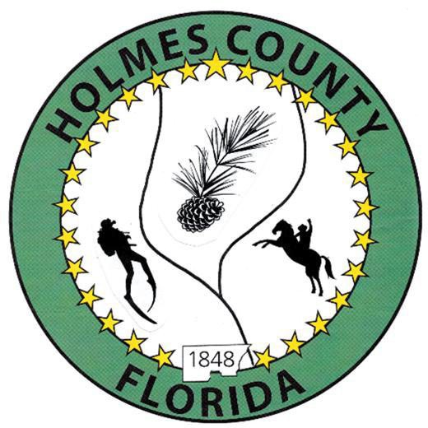
HOLMES COUNTY BOARD OF COUNTY COMMISSIONERS
May 11, 2026 Special Session 2:00PM
Commission Board Room - 107 E Virginia Ave., Bonifay, FL 32425

David Corbin
Project Director
Nate Nolin
County Attorney

WILMER STAFFORD | WADE ELLENBURG | MITCH JOHNSON EARL STAFFORD | CLINT ERICKSON
District 1 | District 2 | District 3 District 4 | District 5

PROCLAMATION
- Call to Order
- Invocation/Pledge

ADOPT THE AGENDA
- Additions or Deletions

ADOPT PREVIOUS MINUTES

NON- AGENDA AUDIENCE
Effective October 1, 2013, Florida Statute 286.0114 mandates that “members of the public shall be given a reasonable opportunity to be heard on a proposition before a Board or Commission.” Each individual shall have three (3) minutes to speak on the proposition before the Board.

AGENDA ITEMS

Library HVAC

Ag Center

County Equipment

COUNTY COORDINATOR

FEMA

BUILDING OFFICIAL / PLANNING

LIBERTY PARTNERS

COUNTY ENGINEER
- Dewberry Engineering
- Melvin Engineering
- Alday – Howell Engineering
- Hanson Professional Services

COUNTY ATTORNEY

COMMISSIONER ITEMS

ADJOURN

