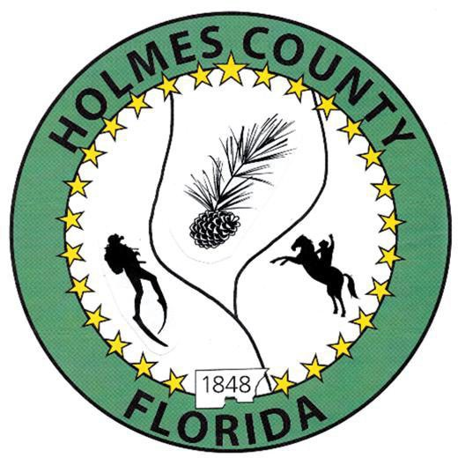**HOLMES COUNTY BOARD OF COUNTY COMMISSIONERS**

**August 12, 2025 Special Session 6:00 PM**

**Ponce De Leon High School – 1477 Ammons Rd., Bonifay, FL 32425**

**David Corbin**

Project Director

**Nate Nolin**

County Attorney

|  |  |  |  |
| --- | --- | --- | --- |
| **WILMER STAFFORD** |  | **MITCH JOHNSON EARL STAFFORD** | **CLINT ERICKSON** |
| District 1 | District 2 | District 3 District 4 | District 5 |

# **PROCLAMATION**

* Call to Order
* Invocation/Pledge

# **ADOPT THE AGENDA**

* Additions or Deletions

# **ADOPT PREVIOUS MINUTES**

# Regular Session August 5, 2025

# 

# **NON- AGENDA AUDIENCE**

Effective October 1, 2013, Florida Statute 286.0114 mandates that “members of the public shall be given a reasonable opportunity to be heard on a proposition before a Board or Commission.” Each individual shall have three (3) minutes to speak on the proposition before the Board.

# **AGENDA ITEMS**

# Lake Cassidy

# **COUNTY COORDINATOR**

# **FEMA**

# 

# **BUILDING OFFICIAL / PLANNING**

# 

# **LIBERTY PARTNERS**

# **COUNTY ENGINEER**

* Dewberry Engineering
* Melvin Engineering
* Alday – Howell Engineering
* Hanson Professional Services

# 

# **COUNTY ATTORNEY**

# 

# **COMMISSIONER ITEMS**

**ADJOURN**